Go to Reports > Assessment > Analysis > Transition Matrix

In this example, KS1 Measures 2017 markbook has been selected along with KS1 En Rea and GLD Pupil? columns.

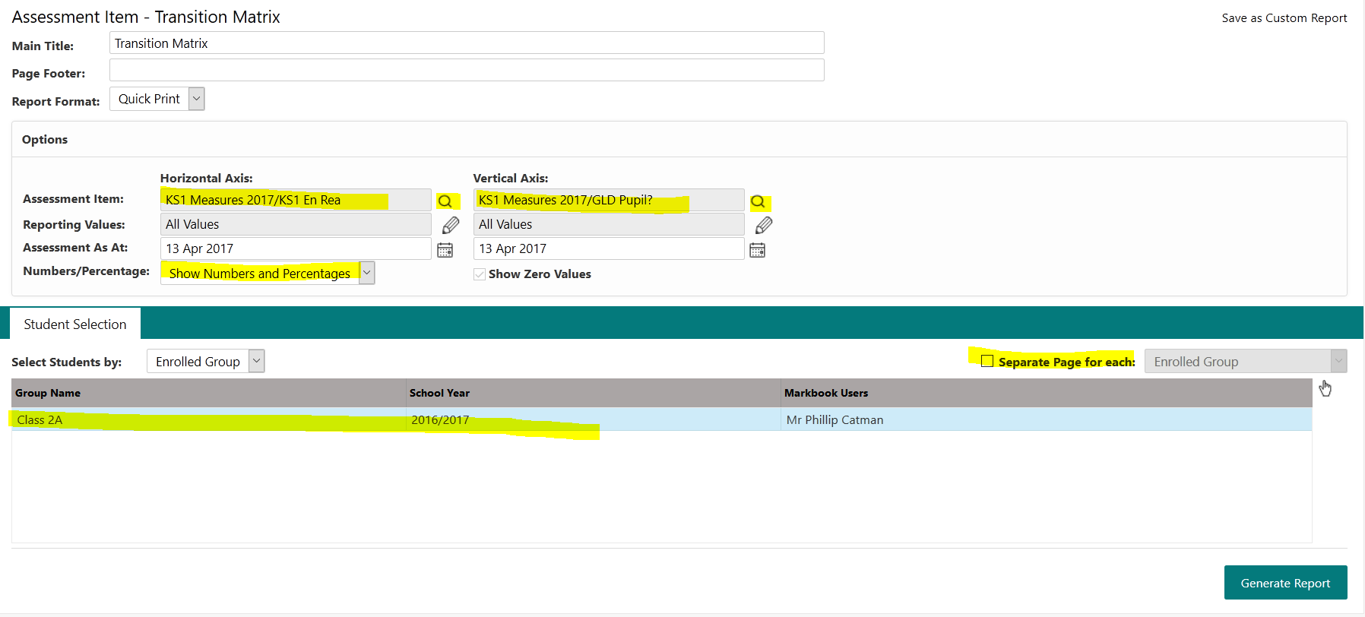

In the criteria screen, do the following:
- Assessment item: For Horizontal axis: click the  - then click on it again and navigate to the user/folder for the markbook you want to use. Then select the column you want to analyse and click OK (as per the Help Reports page instructions in the Performance Dashboard). See overleaf for locations of markbooks to help you with this.
Repeat as above for Vertical axis (note: vertical should reflect the GLD or KS1 starting point)
- Select Show Numbers and Percentages
- Show zero values optional – can be unticked to make report table more readable
- Select pupil group from list
- Click Generate Report (for whole cohort)

- To obtain % figures for groups of pupils, tick box for Separate Page for each and select group from pull-down menu – report will calculate figures for each group on a new page

The report will look like this:

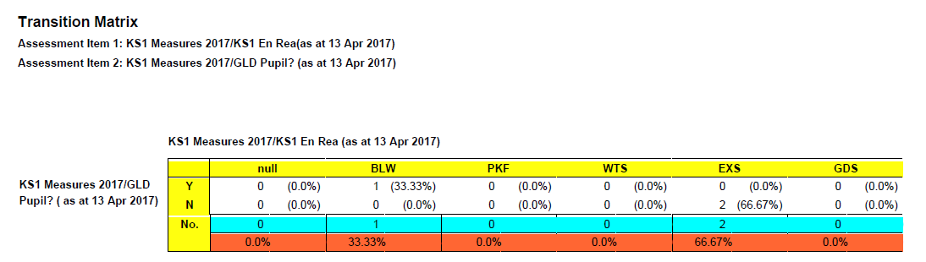

When you are done, you can close any report to return back to the criteria screen

When looking for markbooks – you need to be aware of the user who set them up for you.

When you click on , and click on it again, you will be taken to the following folder structure:

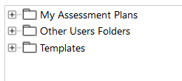

If you have set up the markbooks initially, then you need click + next to ‘My Assessment Plans’ folder to open it (as you will be the user who ‘owns’ the markbook/plan)

If another user – usually the G2 Administrator – has set up the markbook for you, you need to click + next to Other Users Folders and then on + again next to the user name for your G2 Administrator
Then you should see the folders as listed below which will hold the markbooks:

the then click on + next to KS1 2017 folder to locate NC Key Stage 1 2017 book
OR
then click on + next to KS1 Measures folder to locate KS1 Measures 2017
OR
then click on + next to KS2 2017 folder to locate NC Key Stage 2 2017 book
OR
then click on + next to KS2 Measures folder to locate KS2 Measures 2017
OR
then click on + next to Phonics folder to locate NC Phonics Check 2017 book
OR
then click on + next to Early Years folder to locate NC Early Years F 2017 book
OR
then click on + next to EYF from 2014 then + next to EYF GLD folder to locate EYF Measures 2017 book
OR
+ next to Year 4 Return folder to locate CBC Year 4 Return 2017 book
OR
then click on + next to KS2 Measures folder to locate Y4 Measures 2017 book
OR
then click on + next to KS2 Measures folder to locate Y4 CBC Measures 2017 book

