BEFORE YOU START, MAKE A NOTE OF WHO ‘OWNS” THE MARKBOOKS YOU WISH TO ANALYSE (in preparation for step 3 below)
To do this, select the markbook as usual and look across the screen to see the ‘Plan owner’.
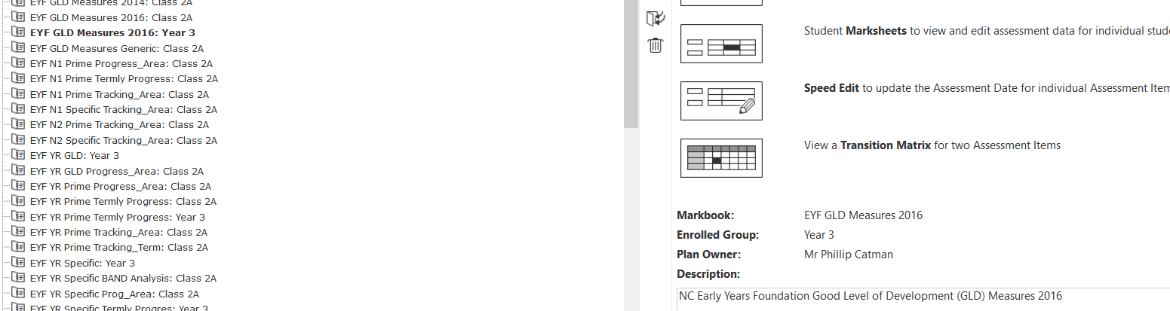
- Go to Modules > Assessment > Analysis > Multiple Assessment Items > click Start Analysis 
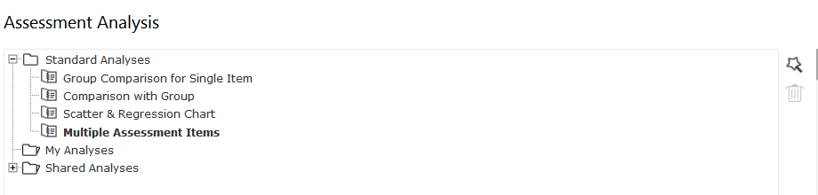
You will see the following screen:

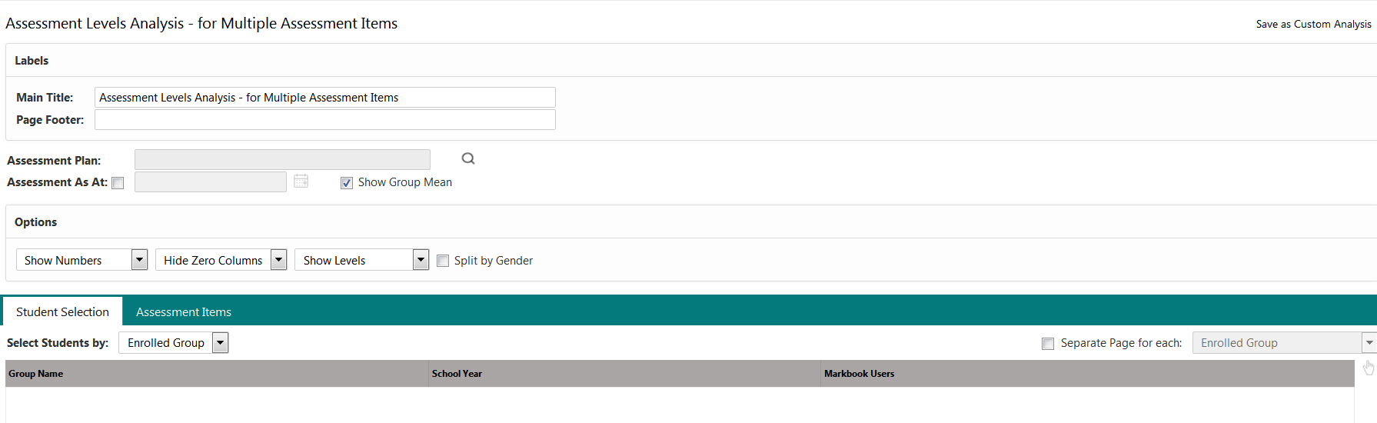

- Click the magnifying glass icon next to the Assessment Plan text box
- Navigate to and select the assessment plan (markbook) you are interested in (Note: you need to open the folder of the user who ‘OWNS’ the plan, usually the G2 Administrator so click on the + next to Other User’s Folders and then on + again next to the user name for your G2 Administrator)
then click on + next to KS1 2017 folder to locate NC Key Stage 1 2017 book
OR
then click on + next to KS1 Measures folder to locate KS1 Measures 2017
OR
then click on + next to KS2 2017 folder to locate NC Key Stage 2 2017 book
OR
then click on + next to KS2 Measures folder to locate KS2 Measures 2017
OR
then click on + next to Phonics folder to locate NC Phonics Check 2017 book
OR
then click on + next to Early Years folder to locate NC Early Years F 2017 book
OR
then click on + next to EYF from 2014 then + next to EYF GLD folder to locate EYF GLD Measures 2017 book
OR
+ next to Year 4 Return folder to locate CBC Year 4 Return 2017 book
OR
then click on + next to KS2 Measures folder to locate Y4 (CBC) Measures 2017 book
- Select the markbook you wish to analyse and click OK
When the markbook is displayed in the Assessment Plan text box, you should see the list of groups children that have been assigned to this markbook in the Student Selection area.
- Select the group of pupils you wish to analyse
- Then click on the Assessment Items tab

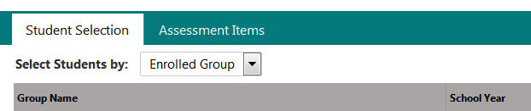

The units and columns as they appear in the markbook selected will be listed here.

- Expand the unit by clicking on the + and then tick the column(s) you wish to analyse.

- One final check – make sure the Report on Lookup Set box displays the same lookup name used for the column(s) you have selected!!!
- Click on Table to see a table similar to this (KS1 example):

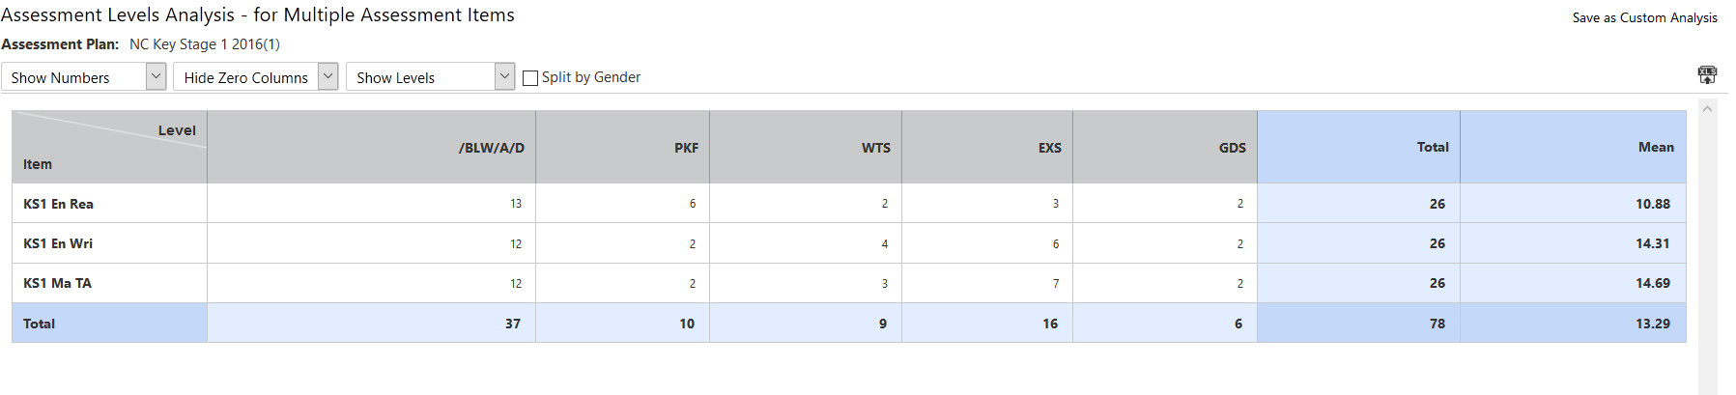

You can now change/interrogate the data in the table:
- change the first drop down menu to display % as well as numbers
- click on a cell to view the children (displayed on the right of the screen) – (any of the pupils lists can be printed)
  - click on a child’s name to view all the results of the child within the table
  - double-click the child’s name to view their Student Profile window
- Change the Show Numbers to Show Pupils to get a ‘hibernation’ sheet in the first drop-down menu – to print this, click on the XLS button to export it to Excel and print from there

To show percentages by different children groups i.e. EAL, SEN, etc.

- Click the Student Selection tab
- Click the tickbox for Separate Page for each and select the group – in the example below, date of birth is selected to eventually show 3 separate tables for autumn, spring and summer born pupils.
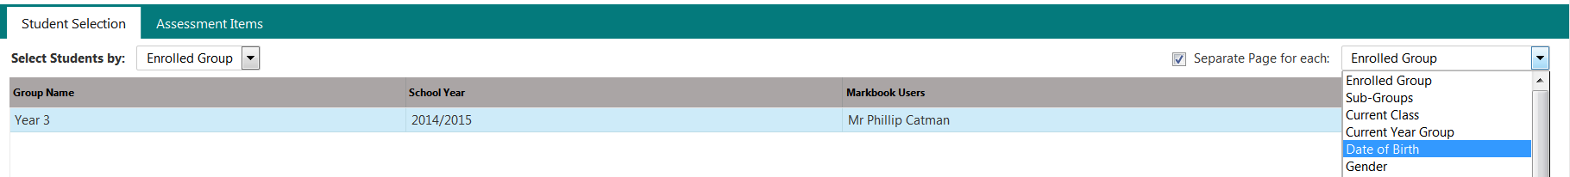
- Then click Table – you will find scroll arrows to take you to each table per group breakdown.

